# Lab 2 – Working with UML Diagrams

## EXERCISE:

**Task#01**

**Design separate UML use case diagram for following scenarios**

1. **Bank ATM (Automatic Teller Machine) System**

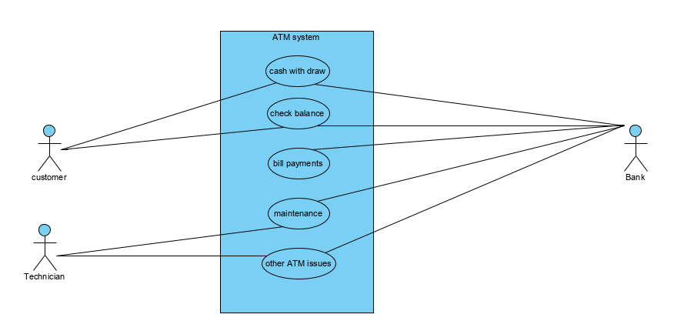

1. **Business Use case diagram for a Restaurant (Considering it from all prospectus like serving food, hiring employees, purchasing raw material etc.)**

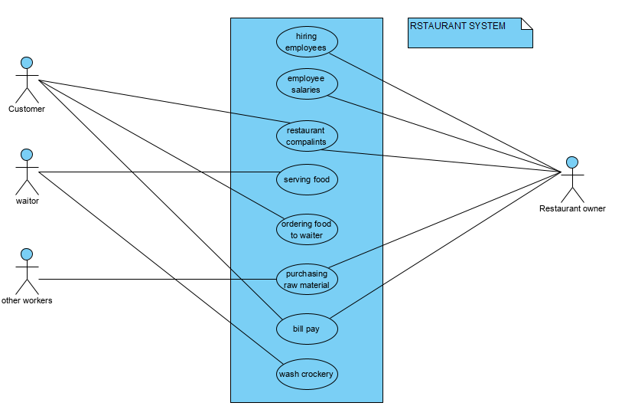

1. **Taking a scenario of your own choice (Note: Same scenario will be used for all UML diagram throughout this practical course)**

**For use case:**

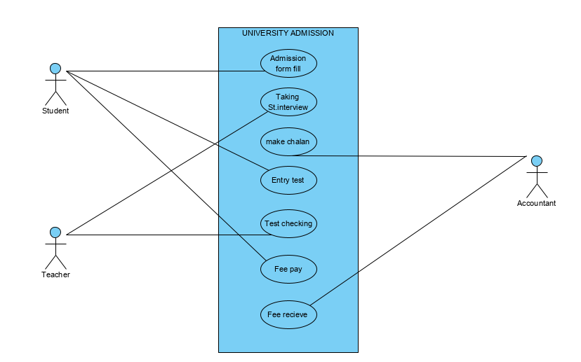

**For Sequence:**

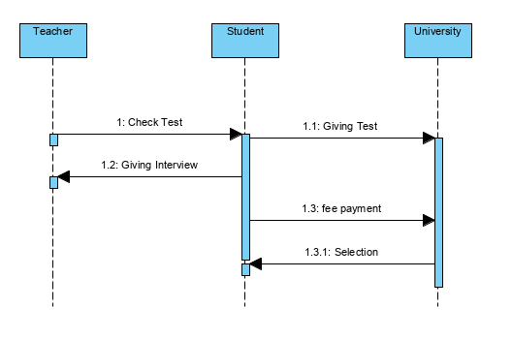

**For Activity:**

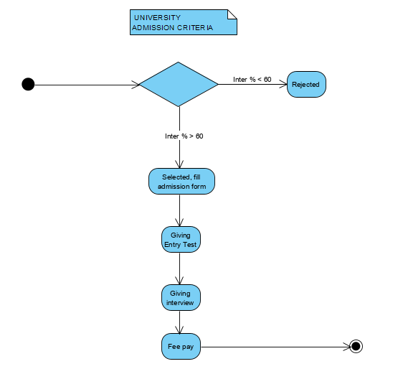

**Task#02**

**What is importance of UML sequence diagram in practical life?**

Every practical life Application implement in sequence diagram because it is easy to explain difficult things to a pictorial view. This is the Importance of a UML sequence diagram in practical life. For example, we take a practical life scenario to explain this…

**Library System:**

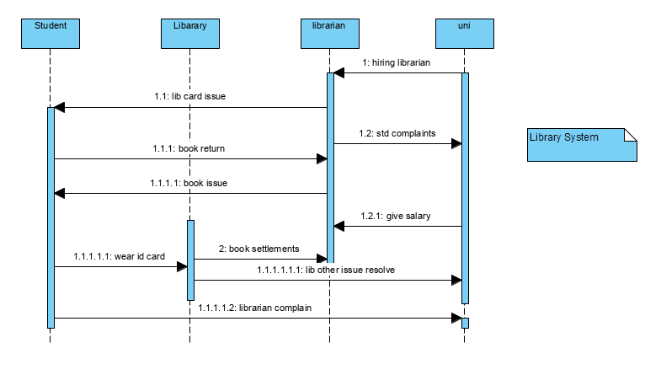

**Task#03**

**Draw an activity diagram (Taking a scenario of your own choice)**

